Story Response - Story Stiffness

Summary Description
This is story response output for a specified range of stories and a selected load case or load combination.

Input Data
Name | StoryResp4
Display Type | Story stiffness | Story Range | All Stories
Load Case | RS | Top Story | Story6
Output Type | Not Applicable | Bottom Story | Base

Plot
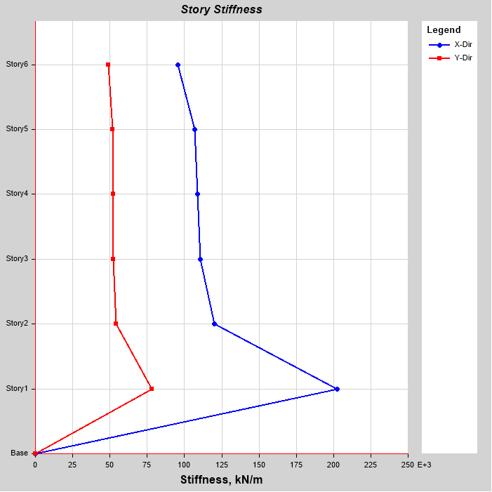

Tabulated Plot Coordinates
Story Response Values

Story | Elevation | Location | X-Dir | Y-Dir
 | m |  | kN/m | kN/m
Story6 | 18 | Top | 95397.685 | 48845.732
Story5 | 15 | Top | 106975.215 | 51768.312
Story4 | 12 | Top | 108593.5 | 52108.681
Story3 | 9 | Top | 110691.09 | 52481.985
Story2 | 6 | Top | 119931.655 | 54238.811
Story1 | 3 | Top | 202378.545 | 78163.385
Base | 0 | Top | 0 | 0

